BLOOD BANK MANAGEMENT SYSTEM

## A PROJECT REPORT

*Submitted by*

# CH.S.K. GOWTHAM

# [Reg No: RA2211027010149]

# S.SAI CHARANI

# [Reg No: RA2211027010186]

*Under the Guidance of*

# DR. SUTHANTHIRA DEVI

Assistant Professor, Department of Data Science and Business Systems

*In partial fulfilment of the requirements for the degree of*

**BACHELOR OF TECHNOLOGY**

**in**

**COMPUTER SCIENCE AND ENGINEERING**

# with a specialization in BIG DATA ANALYTICS



**FACULTY OF ENGINEERING AND**

**TECHNOLOGY**

**SCHOOL OF COMPUTING**

**SRM UNIVERSITY OF SCIENCE AND**

**TECHNOLOGY**

**KATTANKULATHUR**

**MAY 2024**



### **SRM INSTITUTE OF SCIENCE AND TECHNOLOGY KATTANKULATHUR – 603 203**

**BONAFIDE CERTIFICATE**

Certified that this B.Tech project report titled “**BLOOD BANK MANAGEMENT SYSTEM**” is the bonafide work of Mr.C.H.S.K.Gowtham [Reg. No.: RA2211027010149] and Ms. S.SaiCharani [Reg. No.RA2211027010186] who carried out the project work under my supervision. Certified further, that to the best of my knowledge the work reported herein does not form part of any other thesis or dissertation on the basis of which a degree or award was conferred on an earlier occasion for this or any other candidate.

Dr. Suthanthira Devi

Assistant Professor

Department of Data Science and Business Systems

Dr. Lakshmi M

**HEAD OF THE DEPARTMENT**

Department of Data

Science and Business Systems

Relational Schema

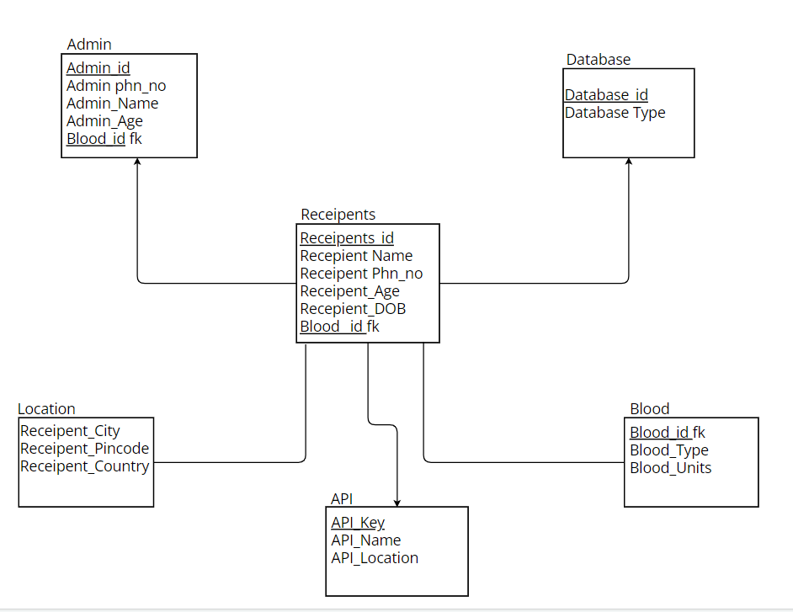

* Admin(Admin_id,First Name,Last Name,Address,Phone_no,Blood_id)
* Database(Database_id,Database Type)
* Receipent(Id,First Name,Last Name,Phn_no,DOB,Age,Blood_id)
* Blood(Blood_id,Blood Type)
* Location(City,Country,Pincode)
* API(API Name,API Key)

Data Base Tables

Admin Table:

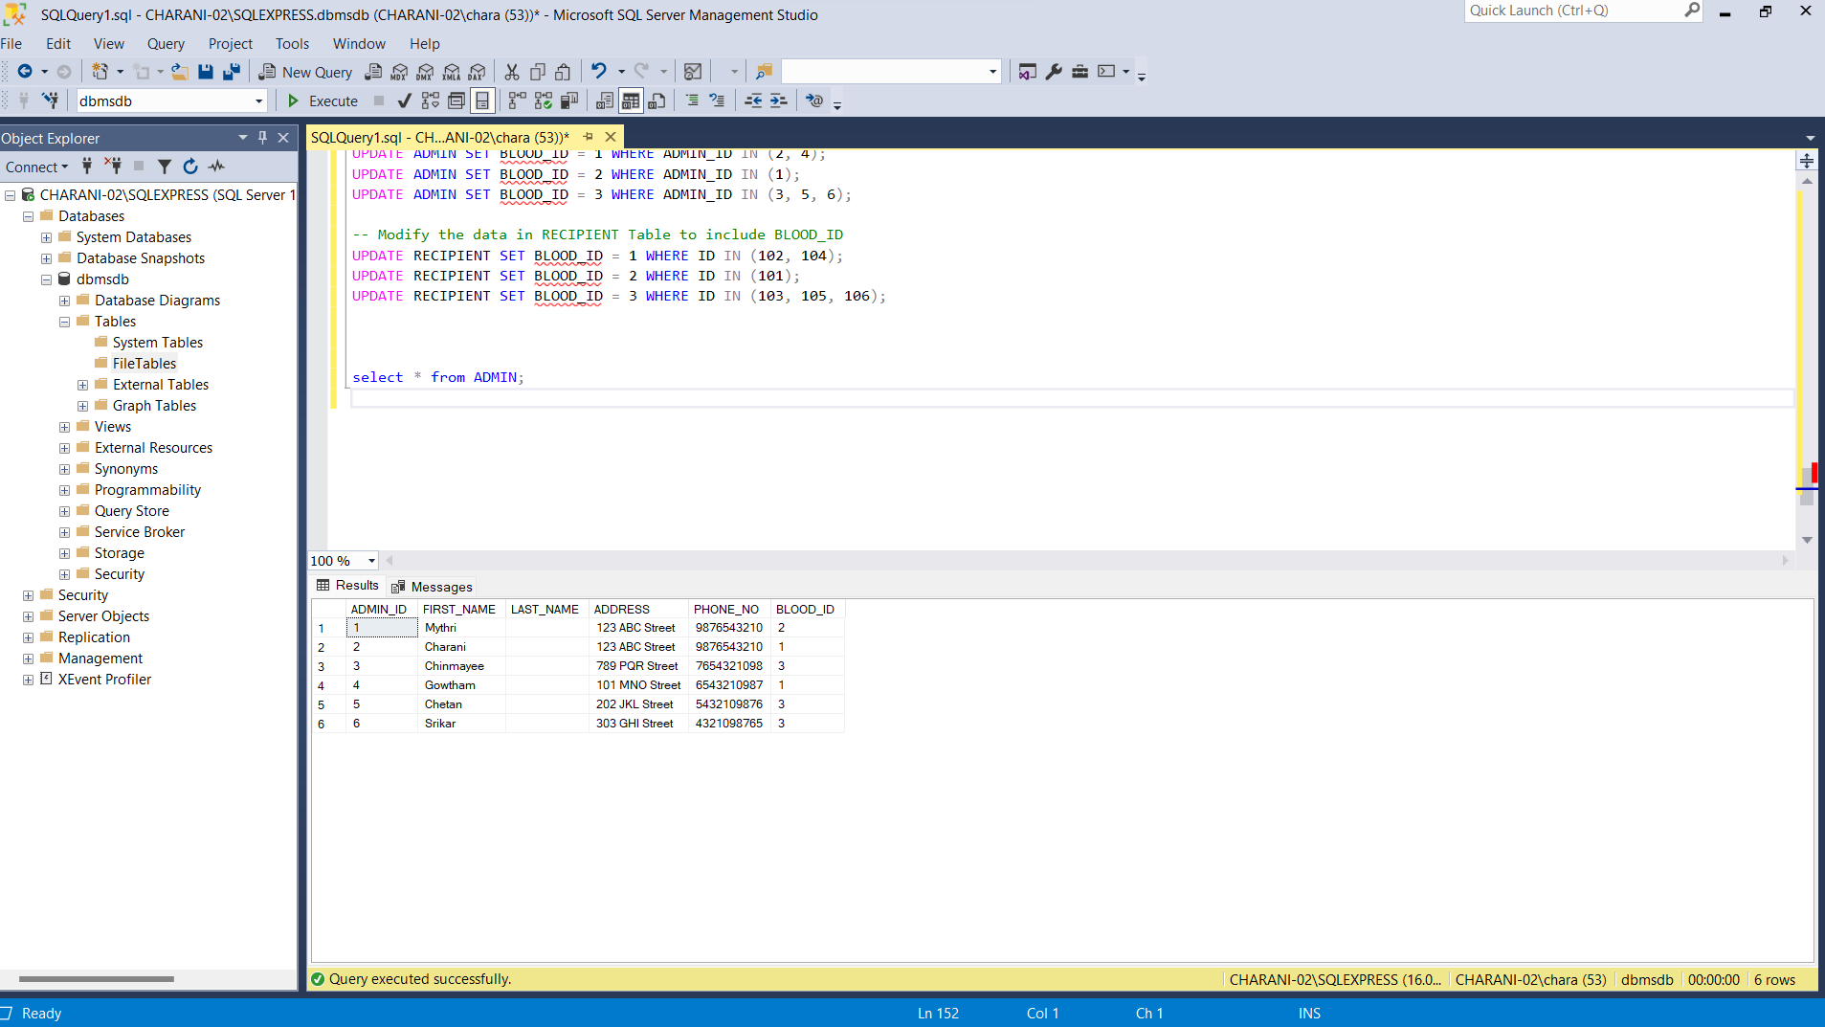

Recipient Table:

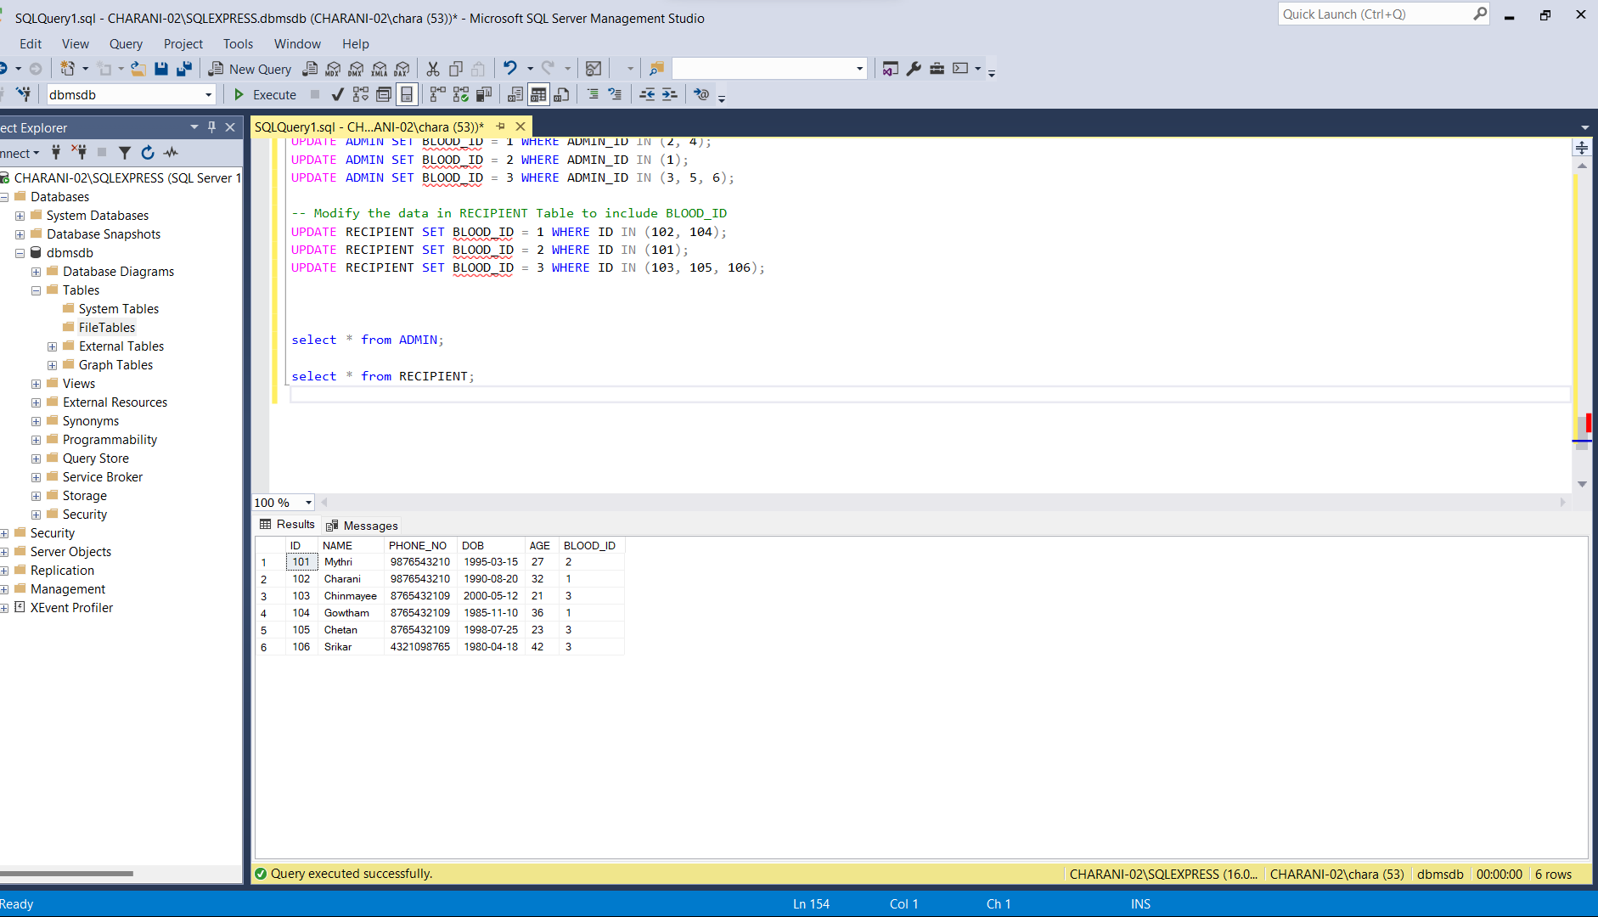

Blood Table:

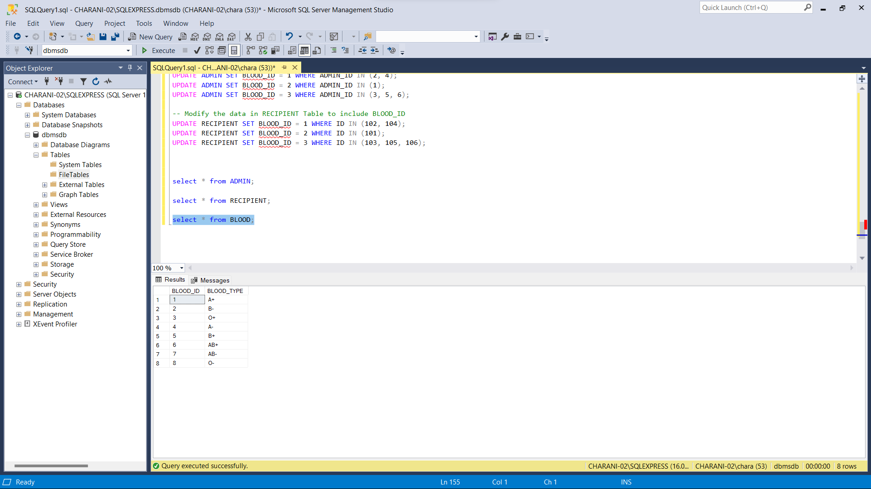

Location Table:

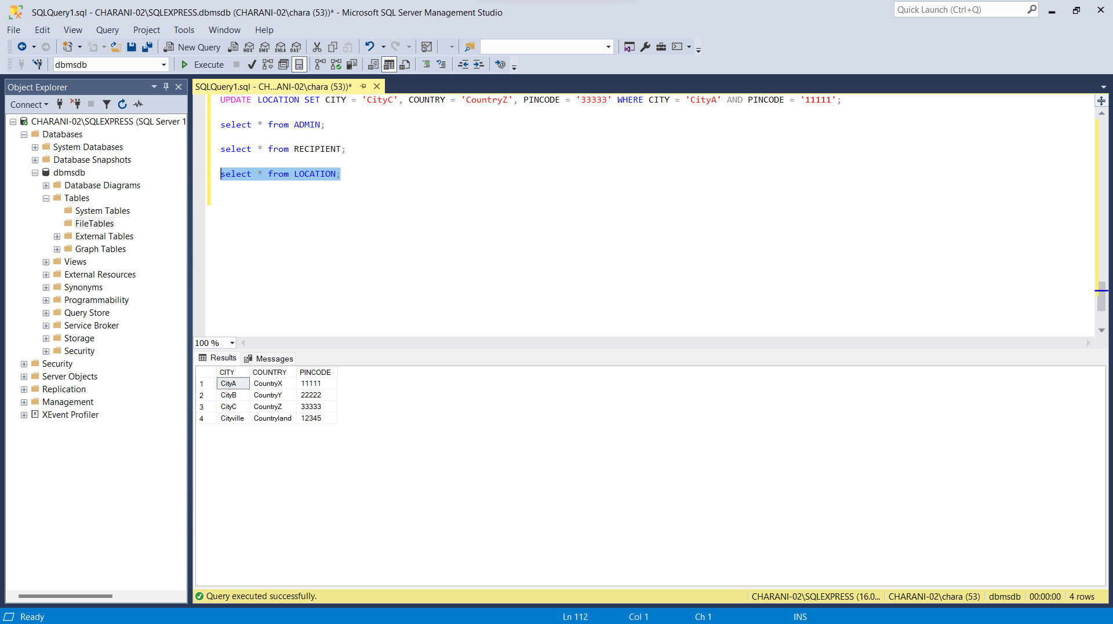

API Table:

